mdg lEDCLOCK (Model 1)

QUICKSTART GUIDE v1.4 01-2022

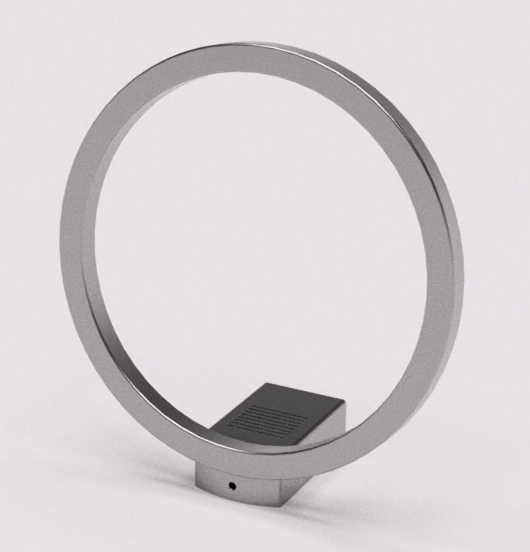

# Index

1 Index 2

2 Introduction 3

3 Setup your clock 4

3.1 Connecting to the clock 4

3.2 Setup your clock 5

4 Using your clock 6

4.1 Connecting to the clock 6

4.2 Create different clock displays 7

4.3 Change display schedules 8

5 MQTT 9

5.1 MQTT Configuration 9

5.2 MQTT TOPICS 10

5.2.1 Display 10

5.2.2 Background 10

5.2.3 Hourmarks 11

5.2.4 Hour 12

5.2.5 Minute 13

5.2.6 Second 14

5.3 Generic MQTT Examples 15

5.4 Home Assistant MQTT example configuration 16

5.5 TLS information 17

# Introduction

First of all thank you for buying this handmade clock which is designed and manufactured in a small workshop in the Netherlands.

I hope you have much fun using this clock!

How to get help

If you have any problems with this clock, please leave us a message at [support@mdg-design.nl](mailto:support@mdg-design.nl) and we will try to help you out.

Latest information and software version can be found at [degraafm76/mdg-ledclock (github.com)](https://github.com/degraafm76/mdg-ledclock)

A word of caution

The body of the clock is made on a 3D-printer with PLA plastic. PLA has a melting temperature of about 60C/140F. Please don’t leave the clock in a car on a hot summer day, or put it next to a heat source. This may deform or permanently damage your clock.

# Setup your clock

Power up your clock by connecting a micro USB cable1 to an USB 5V power source1 with an output of **at least** **1A**. Most phone and tablet USB chargers should work, there is no risk in damaging the clock if an USB charger is used with an output of less than 1A but the clock won’t function correctly.

When the clock is powered on, minutes 0 to 29 will light up white and minute 30 red. This will take about 30 seconds. The red light means that there is no working Wi-Fi connection, and is expected when turning the clock on for the first time. Follow the steps in 3.1 to connect to and configure your clock.

Note: *5 seconds after the red light the clock starts running but of course not on time.*

1 Not included

## Connecting to the clock

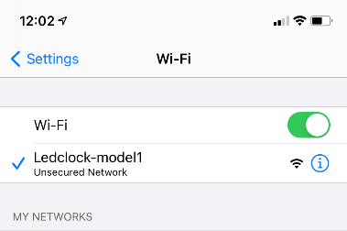When the clock cannot connect to a Wi-Fi network, or the clock is not configured, the clock will start a Wi-Fi network with the   
SSID **‘MDG-Ledclock1’**. Connect to this Wi-Fi network from your mobile phone or pc, the Wi-Fi key for this network can be found on the bottom of the clock. Note: *do not select the option to auto connect to this network.*

When you have a connection to the Wi-Fi network **‘MDG-Ledclock1’** open a browser on the device that has a connection with the Wi-Fi network **‘MDG-Ledclock1’** and go to the following URL: <http://ledclock.local>. When the URL <http://ledclock.local> doesn’t work, you can try to connect to the URL: <http://192.168.4.1>

After a couple of seconds the page as shown in below picture should appear. Open the settings page and follow the instructions in chapter 3.2 tot setup your clock.

## Setup your clock

Press the Scan Networks button (1) and wait until a list of Wi-Fi networks appears. Select your Wi-Fi network and type your Wi-Fi password.

Select your time zone (2) scroll down and press the Save & Reboot button (3). You can leave the MQTT fields emptyfor now. Wait until you see the clock running with the correct time and continue to chapter 4

Note: It can take some time for the clock to show up after there is a Wi-Fi connection (a couple of white leds, and one green)

*Optional settings\**

***Hostname*** *When needed (for example when you have multiple MDG-clocks) you can change the hostname of the clock. When changing the hostname, make sure to only use numbers and letters. Also take a note of the hostname because you need it to connect to the clock. When you change the hostname the URL becomes http://<yourhostname>.local*

***MQTT****MQTT configuration is optional. If you know what an MQTT client is, see chapter 5 for configuration, otherwise leave all MQTT fields default.*

# Using your clock

This chapter describes how you can connect to the clock, how to create different clock displays and how to create schedules to change the clock display after you have setup the clock as described in chapter 3

## Connecting to the clock

Open a web browser and connect to <http://ledclock.local>, after some time the below interface should appear1.

*1: Make sure you are disconnected from the clock’s Wi-fi network and are connected to you own Wi-Fi network. If you changed the hostname as shown in 3.2, please use this to connect to the clock for example <http://yourhostname.local>*

When the above connection method doesn’t work, lookup the clock’s IP-address in your router or DHCP server. When you have found the IP-address of the clock, connect to it with the URL [http://](http://x.x.x.x)*[x.x.x.x](http://x.x.x.x)* where *x.x.x.x* is the IP-address of your clock.

## Create different clock displays

You can create 8 different clock displays and store them in the clock. First select a clock display number, change the colors and settings like auto brightness the way you want them and press the save button.

Note: *Out of the box all 8 position have the same default display colors (blue background, red hours marks and white hour, minute and second hand)*

## Change display schedules

It is possible to change the clock display at specific times. For example: you can have a bright colorful clock display during the day and a very dim display during the night.

To create a schedule open the *Schedules* tab and click on one of the schedules. Select the time (1) and display number*(2) (one of the displays you created in 4.2*) and make sure the active switch (3) is on. You can create a maximum of 12 schedules. If you like to disable a specific schedule at a later time set the active switch to off (3).

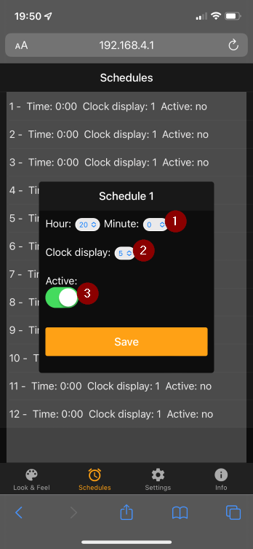

# MQTT

When you have a home automation solution which can function as an MQTT broker for example Home Assistant or Homy u can optionally configure the clock as an MQTT client. This way you can control the clock with your home automation solution.

## MQTT Configuration

Fill in your MQTT broker hostname or IP-address. Fill in your MQTT broker port in, default ports are 1883 (unencrypted) and 8883 (encrypted). If you have MQTT encryption configured on the broker you can enable encryption (TLS). Be aware that when TLS is enabled that the webserver will be disabled.

See chapter 5.5 for TLS notes

## MQTT TOPICS

Commands over MQTT are issued to the ledclock by using the topics and JSON payloads described in this chapter. Replace [hostname] with the configured hostname this is by default: ledclock.

### Display

Display Topics  
State topic: [hostname]/display/state  
Command topic: [hostname]/ display /set

On/Off *JSON Payload:   
{   
 "state": "ON|OFF"   
}*

### Background

Background Topics  
State topic: [hostname]/background/state  
Command topic: [hostname]/background/set

On/Off *JSON Payload:   
{   
 "state": "ON|OFF"   
}*   
  
Brightness  
*JSON Payload:   
{  
"state": "ON",   
"brightness": <1 to 100>  
}*

Color  
JSON Payload:   
*{  
 "state": "ON",  
 "color": {  
 "r": 0 to 255,  
 "g": 0 to 255,  
 "b": 0 to 255  
 }  
}*

Effects *{  
 "state": "ON",  
 "effect": "<effect>"  
}*

Effects: <rgb, rainbow, bpm>

### Hourmarks

Hourmarks topics  
State topic: [hostname]/hourmarks/state  
Command topic: [hostname]/hourmarks/set

On/Off *JSON Payload:   
{   
 "state": "ON|OFF"   
}*   
  
Brightness  
*JSON Payload:   
{  
"state": "ON",   
"brightness": 1 to 100  
}*

Color  
JSON Payload:   
*{  
 "state": "ON",  
 "color": {  
 "r": 0 to 255,  
 "g": 0 to 255,  
 "b": 0 to 255  
 }  
}*

### Hour

Hour topics  
State topic: [hostname]/hour/state  
Command topic: [hostname]/hour/set  
  
On/Off *JSON Payload:   
{   
 "state": "ON|OFF"   
}*   
  
Brightness  
*JSON Payload:   
{  
"state": "ON",   
"brightness": 1 to 100  
}*

Color  
JSON Payload:   
*{  
 "state": "ON",  
 "color": {  
 "r": 0 to 255,  
 "g": 0 to 255,  
 "b": 0 to 255  
 }  
}*

### Minute

Minute topics  
On/Off *JSON Payload:   
{   
 "state": "ON|OFF"   
}*   
  
Brightness  
*JSON Payload:   
{  
"state": "ON",   
"brightness": 1 to 100  
}*

Color  
JSON Payload:   
*{  
 "state": "ON",  
 "color": {  
 "r": 0 to 255,  
 "g": 0 to 255,  
 "b": 0 to 255  
 }  
}*

### Second

Second topic  
[hostname]/second/state  
[hostname]/second/set  
  
On/Off *JSON Payload:   
{   
 "state": "ON|OFF"   
}*   
  
Brightness  
*JSON Payload:   
{  
"state": "ON",   
"brightness": 1 to 100  
}*

Color  
JSON Payload:   
*{  
 "state": "ON",  
 "color": {  
 "r": 0 to 255,  
 "g": 0 to 255,  
 "b": 0 to 255  
 }  
}*

## Generic MQTT Examples

Turn background off:

*Topic: [hostname]/background/set  
JSON Payload:   
{   
 "state": "OFF"   
}*   
Set background brightness to 50%:

*Topic: [hostname]/background/set  
JSON Payload:   
{  
"state": "ON",   
"brightness": 50  
}*

Change color of hour marks to red:

Topic: [hostname]/hourmarks/set   
JSON Payload:   
*{  
 "state": "ON",  
 "color": {  
 "r": 255,  
 "g": 0,  
 "b": 0  
 }  
}*

## Home Assistant MQTT example configuration

light:

- platform: mqtt

schema: json

command_topic: "ledclock/display/set"

state_topic: "ledclock/display/state"

name: 'Led clock'

brightness: true

brightness_scale: 100

effect: true

effect_list:

- auto_brightness

- manual_brightness

- platform: mqtt

schema: json

command_topic: "ledclock/hour/set"

state_topic: "ledclock/hour/state"

name: 'Led clock - hour hand'

brightness: true

color_mode: true

supported_color_modes: ["rgb"]

brightness_scale: 100

- platform: mqtt

schema: json

command_topic: "ledclock/minute/set"

state_topic: "ledclock/minute/state"

name: 'Led clock - minute hand'

brightness: true

color_mode: true

supported_color_modes: ["rgb"]

brightness_scale: 100

- platform: mqtt

schema: json

command_topic: "ledclock/second/set"

state_topic: "ledclock/second/state"

name: 'Led clock - second hand'

brightness: true

color_mode: true

supported_color_modes: ["rgb"]

brightness_scale: 100

- platform: mqtt

schema: json

command_topic: "ledclock/background/set"

state_topic: "ledclock/background/state"

name: 'Led clock - background'

brightness: true

color_mode: true

supported_color_modes: ["rgb"]

brightness_scale: 100

effect: true

effect_list:

- rgb

- rainbow

- bpm

## TLS information

* At the moment it is not possible to upload fingerprints or certificates for server validation.
* In general, TLS 1.2, TLS 1.1, and TLS 1.0 are supported with RSA and Elliptic Curve keys and a very rich set of hashing and symmetric encryption codes.
* When TLS is activated the webserver is stopped however you can continue to configure the clock with a serial connection 115200 baud.